1.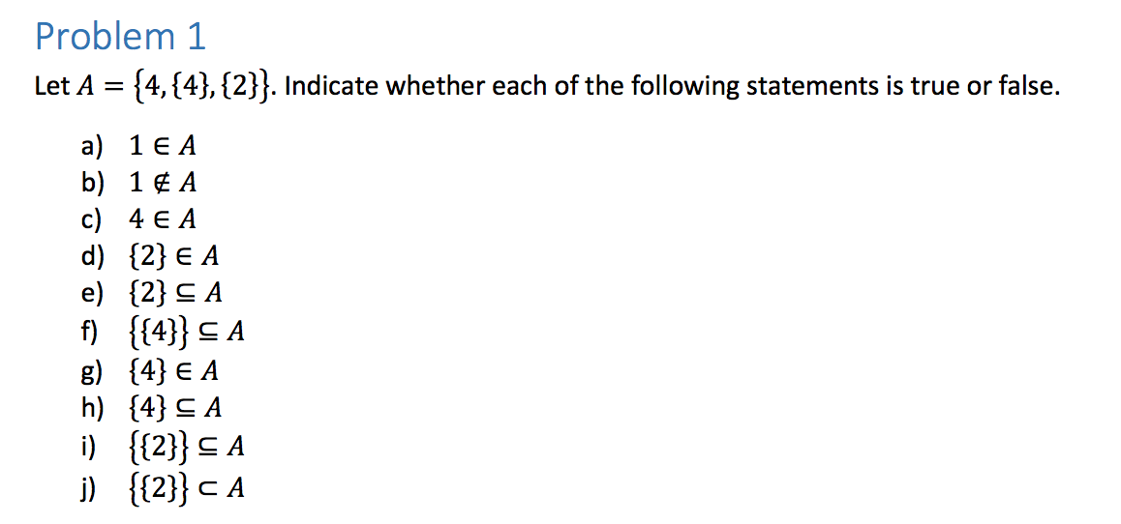

1. False
2. True
3. True
4. True
5. False
6. True
7. True
8. True
9. True
10. True

2. If 𝐴⊆ 𝐵 and 𝐵 ⊄ 𝐶, then 𝐴 ⊄ 𝐶

Let x ε A.

1. 1. A ⊆ B Premise

2. B ⊄ C Premise

3. ∀x (x ε A → x ε B) Definition of Subsets (1)

4. x ε A → x ε B Universal Instantiation (3)

5. ∀x (x ε B→ ¬x ε C)) Definition of Subsets (2)

6. x ε B → ¬ x ε C Universal Instantiation (5)

7. x ε A → ¬ x ε C Law of Syllogism (4)(6)

8. ∀x (x ε A → ¬ x ε C) Universal Generalization (7)

9. A ⊄ C Definition of Subsets (8)

Q.E.D

Therefore, the statement is true.

Prove or Disprove:

A – B = ¬(B – A)

B: {1, 2, 3, 4, 5}

A: {1, 2, 3, 4, 5}

A – B = {}

B – A = {}

Since A and B both equal the null set, A – B = ¬(B- A) is not true.

Therefore, the statement is false.

1. 1. (A ∩ B ∩ C) ⊆ (A ∩ B) Given

2. ∀x (x ε A ^ x ε B ^ x ε C → x ε A ^ x ε B) Definition of Subsets(1)

3. x ε A ^ x ε B ^ x ε C → x ε A ^ x ε B Universal Instantiation (3)

4. x ε A ^ x ε B → x ε A ^ x ε B Conjunctive Simplification(4)

5. Q.E.D.

Therefore, the statement must be true.

d)

Prove or Disprove: 𝐴⊆𝐵 ∧ 𝐴⊆𝐶 → 𝐵∩𝐶≠∅

B: {1, 3, 5, 7, 8}

C: {2, 4, 6, 8}

A: {8}

B ∩ C = {8}

Therefore, the statement above is false.

e) (𝐴∪𝐵)⊆𝐴

A: {1, 3, 5, 7}

B: {2, 4, 6, 8}

A ∪ B = {1, 2, 3, 4, 5, 6, 7, 8}.

Since this is not a subset of A, the statement must be false.

f)

(𝐴∩𝐶)=(𝐵∩𝐶) ⇒ (𝐴=𝐵)

A: {1, 2, 3}

B: {1, 2, 3, 4}

C: {1, 2, 3}

A ∩ C = {1, 2, 3} and A ∩ B = {1, 2, 3}, but A does not equal B.

Therefore, the statement is false.

g) 𝐴 ∪(𝐵 − 𝐴)=(𝐴 ∪ 𝐵)

1. 𝐴 ∪(𝐵 − 𝐴)=(𝐴 ∪ 𝐵)  Given
2. ∀x (x ε A v (∀x (x ε B ^ x ε A)) = A v B Definition of Subsets (1)
3. x ε A v (x ε B ^ x ε A)) = A v B Universal Instantiation (2)
4. x ε A v x ε B Conjunctive Simplification (3)
5. ∀x (x ε A v x ε B) Universal Generalization (4)
6. A ∪ B Definition of Union (5)

Q.E.D

Therefore, the statement is true.

h)

1. (𝐴 ⊆ 𝐵) ⇔ (¬𝐵 ⊆ ¬𝐴)  Given

2. ∀x(x ε A → x ε B) ⇔ ∀x (¬ x ε B → ¬ x ε A) Definition of Subsets (1)

3. x ε A → x ε B ⇔ ¬ x ε B → ¬ x ε A Universal Instantiation (2)

4. ¬ x ε B → ¬ x ε A ⇔ ¬ x ε B → ¬ x ε A Definition of Contraposition(3)

Q.E.D

Therefore, the statement is true.

i) Let x ε A

1. 𝐴 ⊆ (𝐵 – 𝐶) ⇒ (𝐴 ∩ 𝐶=∅)  Given

2. ∀x (x ε A → (∀x(x ε B ^ ¬ x ε C)) → x ε A ^ x ε C = false Definition of Subsets(1)

3. x ε A → (x ε B ^ ¬ x ε C) → x ε A ^ x ε C = false Universal Instantiation (2)

4. ¬x ε A v (x ε B ^ ¬ x ε C) Definition of Implication (3)

5. (¬x ε A ^ x ε B) v (¬x ε A ^ ¬x ε C) Distribution (4)

6. ¬x ε A Absorption (5)

7. ¬x ε A ^ x ε A = False Complementation(6)

Q.E.D

Therefore, the statement is true.

j)

(𝐴 – 𝐶 = 𝐵 − 𝐶)⇒( 𝐴 = 𝐵)

True prove it

A: {2, 8}

B: {3, 8}

C: {2, 3, 4, 5, 6}

The set A – C = {8}, and the set B – C also equals {8}.

However, {2, 8} does not equal {3, 8}, therefore the statement above is false.

k)

Prove or Disprove:

𝐴 ⊆ 𝐵∧ 𝐴 ⊆ 𝐶 ⇒ 𝐴 = ∅ ∨ (𝐵 ∩ 𝐶 ≠ ∅)

A: {1, 2, 4, 6}

B: {1, 2, 4, 6, 8}

C: {1, 2, 4, 6, 7}

Since the set A is not null, and B ∩ C = {1, 2, 4, 6}, the above statement must be false.

3.

Find the sets 𝐴 and 𝐵 if 𝐴 − 𝐵 = {1, 5, 7, 8}, 𝐵 − 𝐴 = {2, 10}, and 𝐴 ∩ 𝐵 = {3, 6, 9}.

Since A ∩ B = {3,6,9) that means they both have 3, 6, and 9.

A: {3, 6, 9}

B: {3, 6, 9}

Since B – A = {2, 10}

This means that B has the elements of 2 and 10 that A does not have.

B: {2, 3, 6, 9, 10}

Since A – B = {1,5,7,8}

A must have the elements 1,5,7 and 8 that B does not have.

**A: {1, 3, 5, 6, 7, 8, 9}**

**B: {2, 3, 6, 9, 10}**

Q.E.D.

4.

a)

P= {φ, 1, {1, 1}, {1, 2}, {1, 6}, {1, 9}, 2, {2, 1}, {2, 2}, {2, 6}, {2, 9}, 6, {6, 1}, {6, 2}, {6, 6}, {6, 9}, 9, {9, 1}, {9, 2}, {9, 6}, {9, 9}, {1, 2, 6}, {1, 2, 6, 9}, {2, 6, 9}}

b)

S x S = {{1, 1}, {1, 2}, {1, 6}, {1, 9}, {2, 1}, {2, 2}, {2, 6}, {2, 9}, {6, 1}, {6, 2}, {6, 6}, {6, 9}, {9, 1}, {9, 2}, {9, 6}, {9, 9}}

5.

a)

S = {x ε Ζ | 2x and x > 0}

b)

S = {2x + 1 | x ε Ζ}

c)

S = {4n + 42 | x ε Ζ and x > 0}